Anaesthesia & Theatres – Clocks Go Forward Action Card

Table of Contents
Theatre Case Times 1
Continuous Medications 2
Anaesthesia Start and Stop Events 2
Device Data 2
Brain 2
Doctors/Prescribers 2
Infusions/Medications 3
When Documenting/Viewing Graphs (especially flowsheets) 3
Rover 3

When the clocks go forward at 01:00AM an hour will be lost. This means you will need to be aware of the impact on medication ordering and administration, graphs, and volume calculations for infusion groups.

NEW! Epic automatically reschedules any medication due times and procedures that fall within the non-existent 2:00AM hour. Note that medication due times and procedures scheduled before or after the non-existent hour are not adjusted.

IMPORTANT! It is safer for any procedures which are likely to span the time when the clocks change to have their anaesthesia record documented on paper and then transferred to Epic after the event.

However certain other areas need awareness / caution:

Theatre Case Times
Case tracking event times will need to be updated manually so that the amount of time between events is accurate, even if this results in the actual event times themselves being inaccurate. It is the length of time between each event which is of importance. If needed, add a nursing note that specifies the actual times at which case tracking events occurred for the patient.

Continuous Medications
Make sure that the total amount of time that the medication was administered is correct, even when it means that the start or stop times recorded are incorrect. Correct start and stop times can be recorded using a comment on the medication administration that notes the actual time.

Anaesthesia Start and Stop Events
Make sure that the interval between events is correct, even when it means that the actual time recorded is incorrect. This ensures that the length of the case is correct. Correct times can be recorded using notes.

Device Data
The paper chart should be scanned into Epic.

Brain

Nurses who use the Brain: when viewing a shift that contains a DST (Daylight Saving Time) event, the hours on the timeline are adjusted and reflect the skipped or additional hour:
- During the spring DST event, there is no 2:00AM hour represented on the timeline. It is not possible to schedule tasks from either the Brain or the Work List during the non-existent 02:00AM hour.

Doctors/Prescribers
- When you order medications/fluids whose schedule spans the spring DST event, you will see a warning that prompts you to review and confirm the order's schedule.

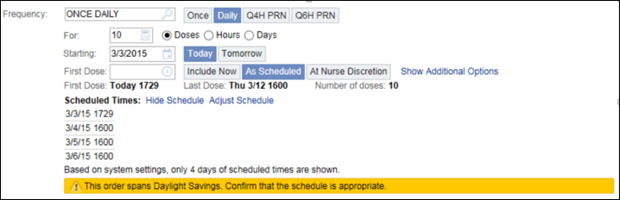

Infusions/Medications

- At 01:00AM any running infusions will be shortened by an hour. This should be considered when determining how much longer the infusion is due to run.
- For patients whose stay overlaps with the DST event, clinicians must manually calculate volumes for infusion groups in the Flowsheets activity. If clinicians attempt to automatically calculate volumes, the system calculation assumes that the infusion was running an hour longer than it was actually running.
- Warnings driven by medication administrations do not take DST time changes into account. As a result, warnings might appear inaccurately or might not appear when users expect them.
- Example: If you administer a medication at 01:59AM and another dose at 03:29AM, because 1hr has been skipped, Epic will treat that these administrations as being ninety minutes apart when in reality only has 30mins lapsed. The best practice advisories that appear when there is less than one hour between medication administration does not appear to let you know that the administrations are too close.

When Documenting/Viewing Graphs (especially flowsheets)

- Staff will not be able to enter flowsheet values between 02:00AM to 03:00AM
- Work List tasks scheduled during the 0200AM will appear overdue after the time change, and you should document these tasks at the appropriate time at 0300AM.
- Graph data over time will continue to show the 2:00AM hour, even though it didn't occur. When evaluating graphs of clinical data over time, the 2:00AM hour did not occur. This includes graphs that appear in:
- Flowsheets
- Results Review
- Synopsis
- Accordion reports

Rover
Some documentation options are unavailable on Rover during the non-existent 02.00 AM hour
Rover can't load medication administrations or work list tasks that the system schedules during the non-existent 02:00 A.M. hour. In addition, you cannot document in a flowsheet time column inserted during the non-existent 02:00 A.M. hour. Any attempts to document a medication administration or task scheduled during the non-existent hour or documents in a flowsheet time column inserted during that time, will produce an error occur.

When using Epic, you are accountable for your decisions and actions. You must always work within the scope of your professional practice (where relevant) and in line with your agreed role remit and competence

